All answers are to be exact, unless stated otherwise.

- Two concentric circles have diameters 18” and 12”. Find the length of a chord of the larger circle which is tangent to the smaller circle.

- Find the distance from the center of a circle to a chord 30M long if the diameter of the circle is 34M.

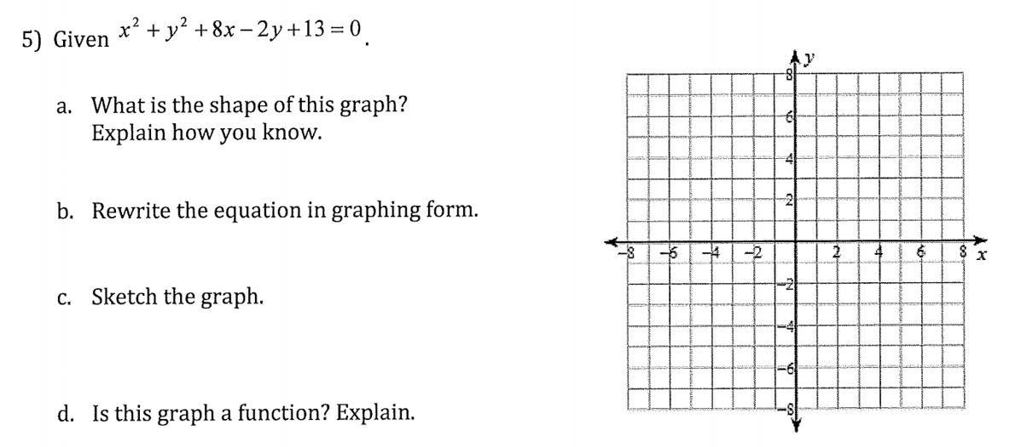

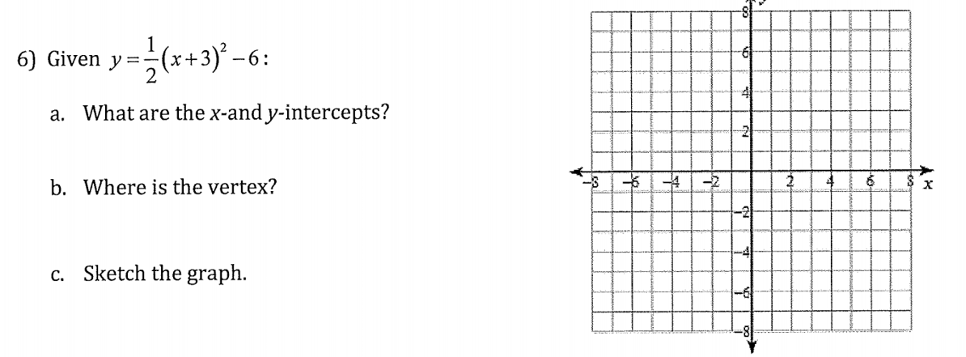

6b. If the line y = 2x + 1 was graphed, where would it intersect the parabola? Solve algebraically.

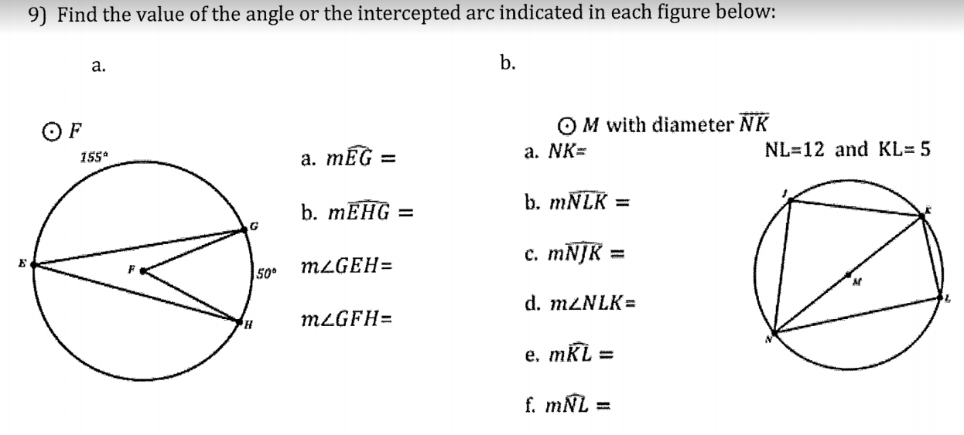

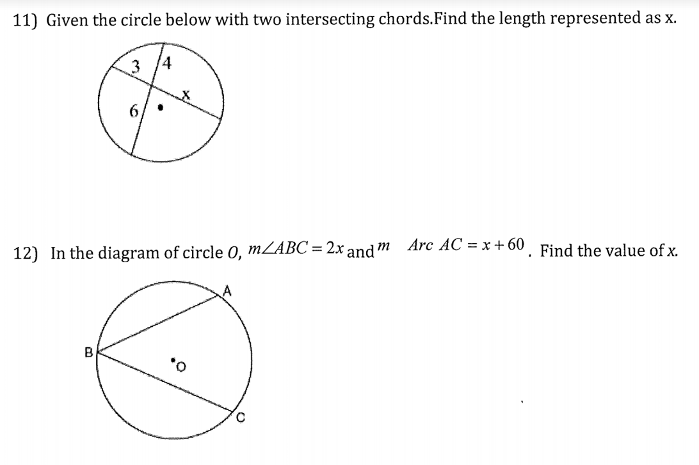

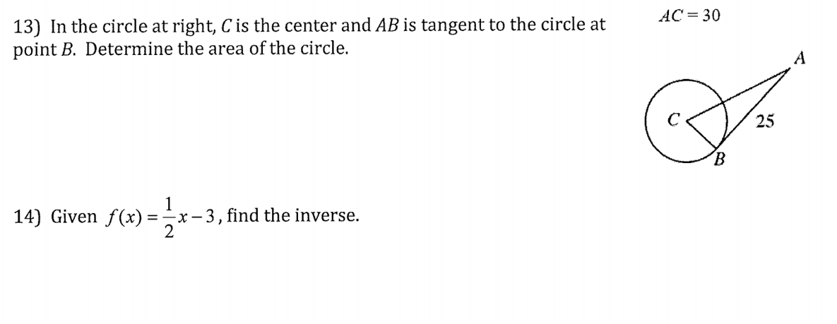

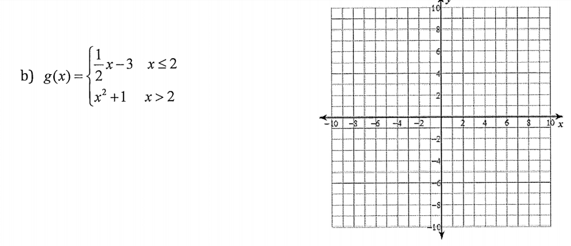

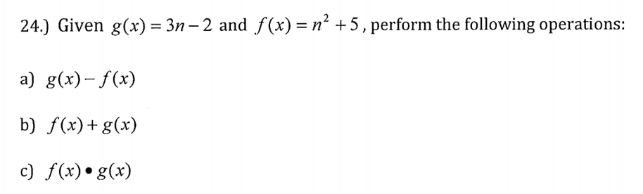

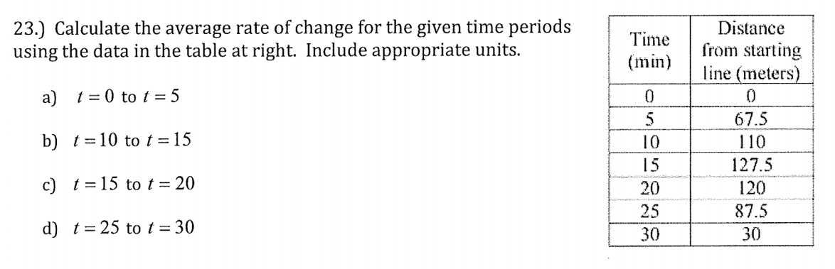
c) t = 17.5

d) t = 25

